Here, we have considered, HWQUPC implementation, where the new connection is made to the tree which is taller. Path compression implies that the tree is connected directly to the parent root node instead of the child.

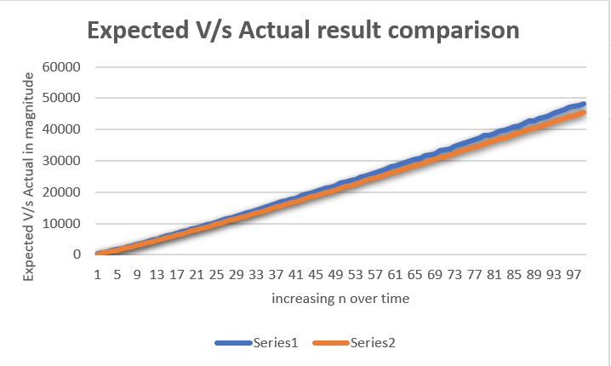

Here, **Series 1** is the **actual value** and **Series 2** is the **expected value** and we see that, expected and actual values are almost equal.

Here, the number of sites i.e. N in increased. Then random pairs of integers between 0 and n-1 are generated, connected() is called to determine if they are connected then union() if not. The final value is the number of times the loop runs until all sites are connected then print the number of connections generated.

Hence, we can say that the number of pairs generated to accomplish this (i.e. to reduce the number of components from n to 1) is ~ 1/2 n log n where log n is the natural logarithm of n, holds true.

PFB table for reference values:

|  |  |  |
| --- | --- | --- |
| N | Actual | Expected[(N/2)*log(N)] |
| 100 | 259 | 230.2585093 |
| 200 | 583 | 529.8317367 |
| 300 | 935 | 855.5673712 |
| 400 | 1329 | 1198.292909 |
| 500 | 1703 | 1553.652025 |
| 600 | 2103 | 1919.078897 |
| 700 | 2518 | 2292.878117 |
| 800 | 2912 | 2673.844691 |
| 900 | 3317 | 3061.077643 |
| 1000 | 3750 | 3453.877639 |
| 1100 | 4143 | 3851.686002 |
| 1200 | 4613 | 4254.046101 |
| 1300 | 5059 | 4660.577703 |
| 1400 | 5518 | 5070.959261 |
| 1500 | 5955 | 5484.91529 |
| 1600 | 6395 | 5902.207127 |
| 1700 | 6821 | 6322.626001 |
| 1800 | 7359 | 6745.987749 |
| 1900 | 7723 | 7172.128707 |
| 2000 | 8171 | 7600.90246 |
| 2100 | 8650 | 8032.177255 |
| 2200 | 9183 | 8465.833903 |
| 2300 | 9618 | 8901.764062 |
| 2400 | 9989 | 9339.86882 |
| 2500 | 10523 | 9780.057514 |
| 2600 | 11057 | 10222.24674 |
| 2700 | 11399 | 10666.35952 |
| 2800 | 11892 | 11112.32457 |
| 2900 | 12423 | 11560.07572 |
| 3000 | 12891 | 12009.55135 |
| 3100 | 13377 | 12460.69396 |
| 3200 | 13796 | 12913.44974 |
| 3300 | 14240 | 13367.76828 |
| 3400 | 14660 | 13823.60221 |
| 3500 | 15373 | 14280.90693 |
| 3600 | 15772 | 14739.64042 |
| 3700 | 16297 | 15199.76298 |
| 3800 | 16882 | 15661.23706 |
| 3900 | 17234 | 16124.02707 |
| 4000 | 17688 | 16588.09928 |
| 4100 | 18051 | 17053.42162 |
| 4200 | 18828 | 17519.96359 |
| 4300 | 19421 | 17987.69615 |
| 4400 | 19678 | 18456.5916 |
| 4500 | 20142 | 18926.62352 |
| 4600 | 20712 | 19397.76664 |
| 4700 | 21230 | 19869.9968 |
| 4800 | 21635 | 20343.29087 |
| 4900 | 22194 | 20817.62669 |
| 5000 | 22904 | 21292.98298 |
| 5100 | 23243 | 21769.33934 |
| 5200 | 23705 | 22246.67615 |
| 5300 | 24023 | 22724.97456 |
| 5400 | 24728 | 23204.21643 |
| 5500 | 25066 | 23684.38427 |
| 5600 | 25722 | 24165.46125 |
| 5700 | 26240 | 24647.43114 |
| 5800 | 26791 | 25130.27827 |
| 5900 | 27261 | 25613.98751 |
| 6000 | 28061 | 26098.54424 |
| 6100 | 28359 | 26583.93435 |
| 6200 | 28944 | 27070.14417 |
| 6300 | 29335 | 27557.16047 |
| 6400 | 30083 | 28044.97046 |
| 6500 | 30453 | 28533.56173 |
| 6600 | 30779 | 29022.92226 |
| 6700 | 31624 | 29513.0404 |
| 6800 | 32005 | 30003.90483 |
| 6900 | 32164 | 30495.50458 |
| 7000 | 33154 | 30987.829 |
| 7100 | 33442 | 31480.86772 |
| 7200 | 33824 | 31974.6107 |
| 7300 | 34663 | 32469.04814 |
| 7400 | 35228 | 32964.17053 |
| 7500 | 35601 | 33459.96862 |
| 7600 | 36120 | 33956.4334 |
| 7700 | 36866 | 34453.55609 |
| 7800 | 37202 | 34951.32815 |
| 7900 | 38009 | 35449.74125 |
| 8000 | 38221 | 35948.78728 |
| 8100 | 38772 | 36448.45833 |
| 8200 | 39491 | 36948.74668 |
| 8300 | 39736 | 37449.64479 |
| 8400 | 40439 | 37951.14534 |
| 8500 | 40867 | 38453.24113 |
| 8600 | 41254 | 38955.92517 |
| 8700 | 41963 | 39459.19063 |
| 8800 | 42690 | 39963.0308 |
| 8900 | 42888 | 40467.43917 |
| 9000 | 43501 | 40972.40935 |
| 9100 | 43970 | 41477.9351 |
| 9200 | 44298 | 41984.01031 |
| 9300 | 45238 | 42490.62901 |
| 9400 | 45761 | 42997.78535 |
| 9500 | 46217 | 43505.47362 |
| 9600 | 47045 | 44013.68821 |
| 9700 | 47369 | 44522.42365 |
| 9800 | 47731 | 45031.67456 |
| 9900 | 48283 | 45541.43568 |